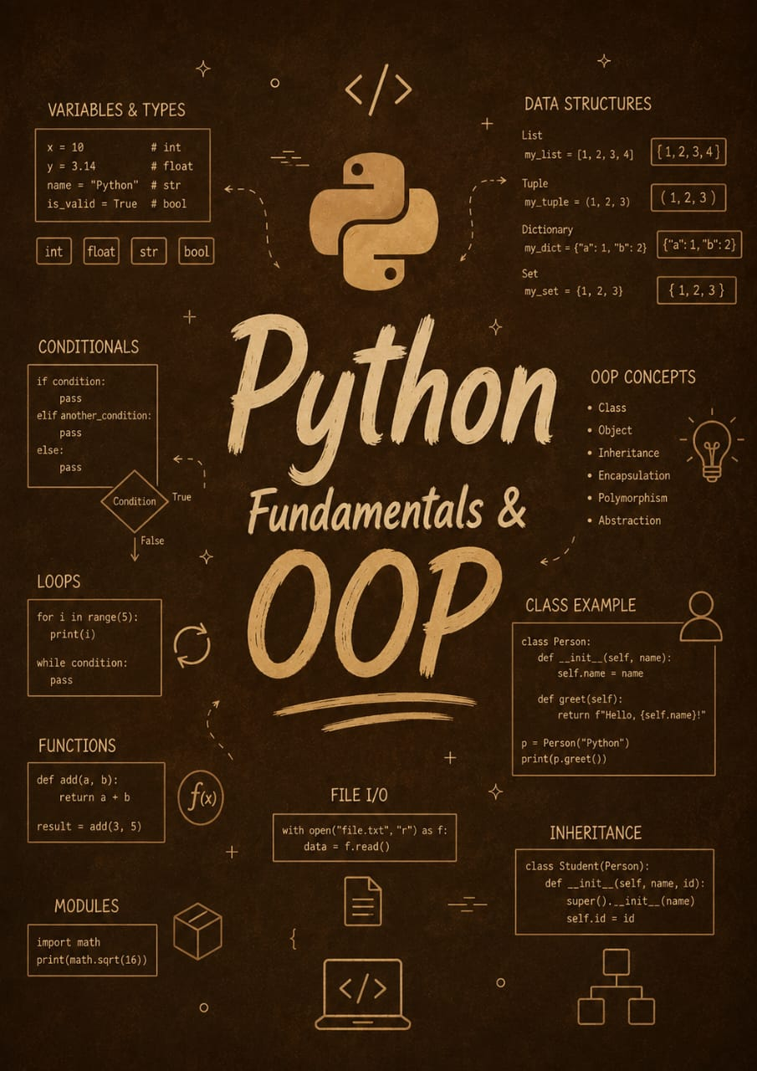

Python Fundamentals and Object Oriented Programming

By Jawad Jammoul

